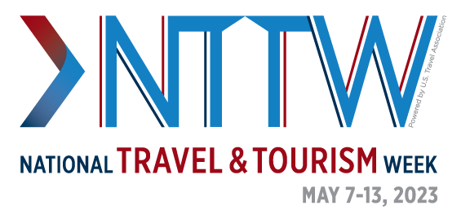
National Travel and Tourism Week 2023 Sample Proclamation
WHEREAS the travel industry fuels every industry and will continue to be an essential part of [STATE/DESTINATION]’s economy, development and workforce.
WHEREAS travel is an economic powerhouse for every state and destination across the country, with an economic output of $2.6 trillion in 2022, supporting 14.5 million American jobs.
WHEREAS travel spending supports vibrant and safe communities in [STATE/DESTINATION] and across the United States by generating $84 billion in state and local tax revenue in 2022 to support essential services, such as education, emergency response, public safety and more.
WHEREAS travel enables success for all industries—including manufacturing, agriculture, defense, healthcare and more—by driving sales growth, innovation, education and operations that move our economy, our nation and [STATE/DESTINATION] forward.

WHEREAS [INSERT STATE/DESTINATION DATA ON DECLINE IN TRAVEL-GENERATED SPENDING, TAX RECEIPTS, EMPLOYMENT AND PAYROLL].
WHEREAS the travel industry cannot recover without the full return of leisure, business and international inbound travelers; increasing travel to and within the United States drives America forward to a more prosperous future.
WHEREAS the travel industry’s success will grow [STATE/DESTINATION]’s economy and workforce, since, prior to the pandemic, small businesses accounted for 60% of leisure and hospitality employment.
WHEREAS travel is an essential industry, and we must continue to communicate that growing travel leads to economic growth, benefits businesses and fosters mutual understanding.
Therefore, I, [OFFICIAL’S NAME AND TITLE], do hereby proclaim May 7-13, 2023 as National Travel and Tourism Week in [STATE/DESTINATION], and urge the citizens of [STATE/DESTINATION] to join me in recognizing the critical role this industry plays in [STATE/DESTINATION].

