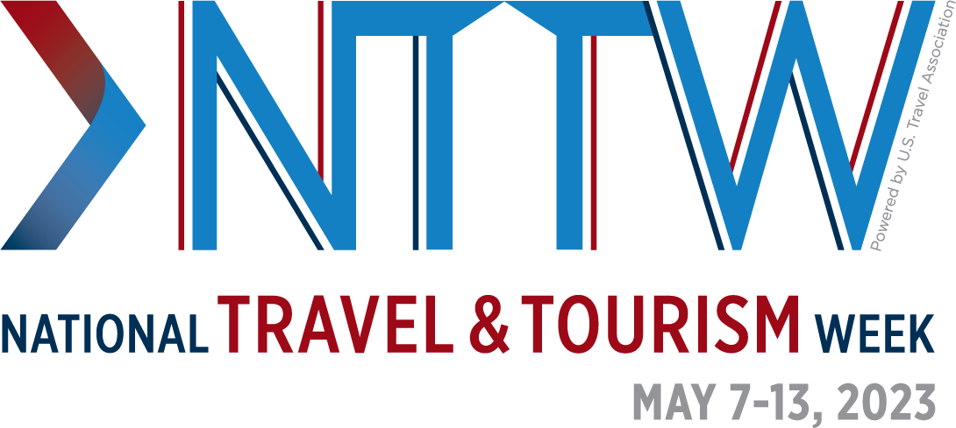

[DESTINATION/ORGANIZATION] Moves Travel Forward This National Travel and Tourism Week
This year marks the 40th anniversary of the annual industry celebration

[CITY, STATE][DATE] — National Travel and Tourism Week, (NTTW) the annual celebration of the contributions of the U.S. travel industry, will spotlight the essential role that travel will play in driving economic growth and innovation through the theme #TravelForward.

“The travel industry fuels every industry—our industry’s success is the nation’s success,” said U.S. Travel Association President and CEO Geoff Freeman. “This week is a prime opportunity to elevate the message that travel is essential to moving America’s economy forward.”

Established in 1983, NTTW is an annual tradition to mark the U.S. travel industry’s role in stimulating economic growth, cultivating vibrant communities, creating quality job opportunities, stimulating business activity and elevating the quality of life for everyday Americans.

Travel serves as a catalyst for a productive U.S. economy and helps power the success of other industries. The U.S. travel industry generated a $2.6 trillion economic output in 2022 and supported 15 million jobs, fueling communities, small businesses and working families across the country.

Travel spending also generated nearly $160 billion in federal, state and local taxes in 2022—revenue that helped fund critical public services while saving each U.S. household an average of $1,270 in taxes.

In [DESTINATION] the travel industry drives [STATE AND OR LOCAL ECONOMIC IMPACT].

[DESTINATION/ORGANIZATION] is recognizing travel’s essential contributions by [PROVIDE BRIEF DESCRIPTION OF ACTIVITIES].

Said [PRESIDENT/CEO/SPOKESPERSON]: “Travel is at the heart of [DESTINATION], powering a strong U.S> economy, creating jobs and strengthening our community’s culture and identity. This National Travel and Tourism Week, we are proud to celebrate all that travel does for our community now, and all that it will contribute in the future.”

Please visit ustravel.org/NTTW to learn more about National Travel and Tourism Week.

