SAMPLE PROCLAMATION

How to use: This sample proclamation is designed for use by local city councils, Mayors, state legislatures or Governors. Draft your proclamation using the outline below, replacing text in red with destination/organization-specific details. Feel free to tweak remaining copy as you see fit before sending to your elected officials. If your elected body issues a proclamation, be sure to notify us at bkemp@ustravel.org.

Useful resources: U.S. Travel’s Economic Impact Map and Travel Economic Impact Calculator.

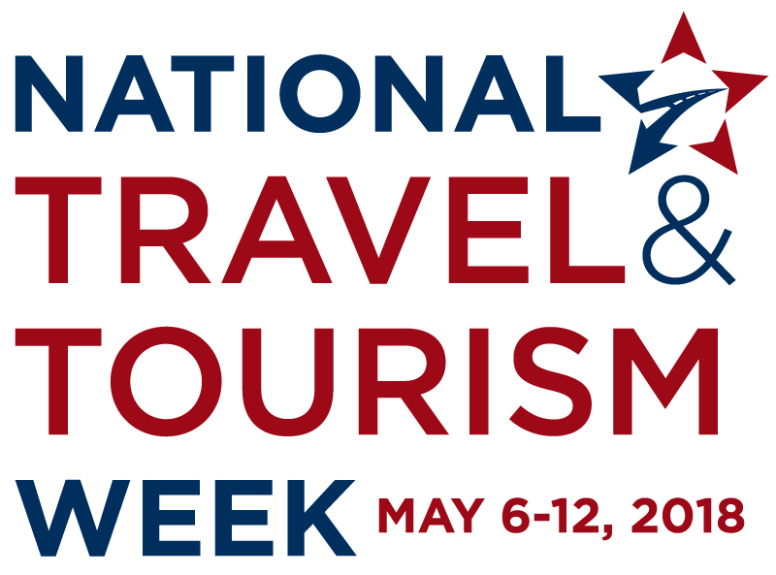

Whereas travel has a positive effect on INSERT STATE and the nation’s economic prosperity and image abroad, it also impacts business productivity and to individual travelers’ well-being.

Whereas travel to and within the United States provides significant economic benefits for the nation, generating more than $2.4 trillion in economic output in 2017, with nearly $1 trillion spent directly by travelers.

Whereas travel is among the largest private-sector employers in the United States, supporting 15.6 million jobs in 2017, including 8.8 million directly in the travel industry and 6.8 million in other industries.

Whereas travelers’ spending directly generated tax revenues of $164.8 billion for federal, state and local governments, funds used to support essential services and programs.

Whereas INSERT STATE/CITY DATA ON ANNUAL TRAVEL-GENERATED SPENDING, TAX RECEIPTS, EMPLOYMENT AND PAYROLL

Whereas International travel to the United States is the nation’s number one services export, and number two overall.

Whereas meetings, events and incentive travel are core business functions that help companies strengthen business performance, educate employees and customers and reward business accomplishments—which in turn boosts the U.S. economy. In 2017, domestic and international business travelers spent $317.2 billion.

Whereas leisure travel, which accounts for more than three-quarters of all trips taken in the United States, spurs countless benefits to travelers’ health and wellness, creativity, cultural awareness, education, happiness, productivity and relationships.

Whereas travel is a pillar of economic growth, creating jobs at a faster rate than other sectors.

Whereas welcoming visitors from near and far always has been, and always will be, the enduring ethos of the travel industry and CITY/STATE.
Now, therefore, I OFFICIAL’S NAME AND TITLE do hereby proclaim May 6-12 as National Travel and Tourism Week in INSERT CITY / STATE, and urge the citizens of INSERT CITY / STATE to join me in this special observance with appropriate events and commemorations.

[AFFIX SEAL]
Governor / Mayor

YOUR LOGO

